INSPIRE
...to be the best YOU!

AQUATICS
(Aquatic Center)
Time | Monday | Tuesday | Wednesday | Thursday | Friday
8:00 - 8:45am | Tidewater Aerobics  (advanced) | Tidewater Aerobics (advanced) | Saltwater Circuit  (advanced) | Tidewater Aerobics (advanced) | Tidewater Aerobics  (advanced)
10:00 - 10:45am | Supervised Swim  (all residents) | 3:00 - 3:45pm  Headwater Aerobics  (beginner) | Supervised Swim  (all residents) | 3:00 - 3:45pm Headwater Aerobics  (beginner) | Supervised Swim  (all residents)

GROUP EXERCISE
(Wellness Studio & Fitness Center)
Time | Monday | Tuesday | Wednesday | Thursday | Friday
9:00 -  9:45am | Circuit Training  (advanced) | Beat Today  (pre-approval) | Cardio & Strength Conditioning  (advanced) | Beat Today  (pre-approval) | Circuit Training  (advanced)
10:00 -10:45am | Yoga  (beginner) | Bay Balance  (advanced) | Yoga  (advanced) | Bay Balance  (advanced) | Yoga  (all residents)
11:00 -  11:45am | Functional Fitness  (beginner) | 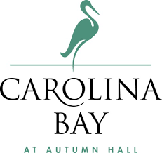 | Functional Fitness  (beginner) |  | Functional Fitness  (beginner)
1:00 -  1:45pm | 1:30 – 2:00pm  Golf Training | Personalized Assessments, Exercise Plans  & Orientations  (by appointment) | Personalized Assessments, Exercise Plans  & Orientations  (by appointment) | Personalized Assessments, Exercise Plans & Orientations  (by appointment) | 1:30 – 2:00pm  Golf Training
2:00 -  2:45pm | Guided Meditation  (all residents) | Bay Balance  (beginner) | 3:00 – 3:45pm  Carolina Cruisers Walking Club  (advanced) | Bay Balance  (beginner) | Guided Meditation  (all residents)

Inspirational
Nutritional
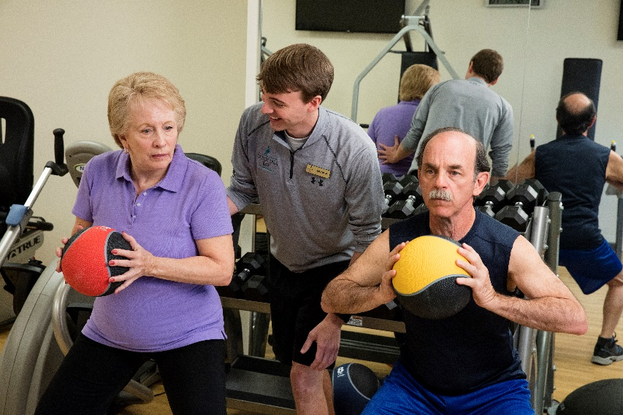
Spiritual
Personal
Integrative
Rehabilitative
Educational

To begin participating, call INSPIRE Wellness Program Director,
Nate Futrell at 769-7511 to schedule your
INSPIRE ASSESSMENT & ORIENTATION today!

